E-COMMERCE WEBSITE
@CREATIVITY THINK (9483175986/7019689991)

ABSTRACT:
The E-commerce Website is a full-stack product-based selling platform designed to support online stores, service shops, and food delivery businesses. The system enables users to browse products, manage cart items, complete checkout through a dummy payment flow, track orders, and leave product reviews. The platform includes both User and Admin roles: Users perform shopping and ordering functionalities, while Administrators manage products, inventory, orders, user accounts, and analytics. Built using Django and Django REST Framework for backend business logic and React with Redux for state management on the frontend, this platform is modern, scalable, secure, and optimized for real-time e-commerce operations..

INTRODUCTION OF THE PROJECT:
With digital shopping becoming the standard for businesses, having a reliable e-commerce solution is essential. Many small and medium sellers struggle with outdated systems lacking cart management, order tracking, analytics, and secure payment flow. This E-commerce Website addresses these challenges through a structured and interactive system that allows seamless product browsing, ordering, reviews, and analytics. The backend handles all product, cart, and order operations, while the frontend ensures a smooth shopping experience similar to modern online stores. The addition of dummy Stripe payment flow helps simulate real-world checkout processes without actual transactions..

PROJECT OBJECTIVES:

• Provide a complete online shopping experience with product browsing and ordering.
• Implement cart management, checkout, and dummy payment workflow.
• Allow users to view order history and write product reviews.
• Provide administrators tools to add, edit, and manage products efficiently.
• Track and manage inventory levels in real time.
• Enable admin to monitor sales analytics through dashboards.

PROBLEM OF THE STATEMENT:
Traditional local businesses struggle to reach online customers due to the absence of modern e-commerce systems. Many available solutions are expensive, complex, or lack essential features like reviews, analytics, or effective inventory management. Furthermore, manual order management often leads to delays and inaccuracies. This E-commerce Website solves these problems by offering a structured, lightweight, scalable, and feature-rich system with complete product management, cart operations, dummy payment workflow, order history, reviews, and dashboards for business insights..

MOTIVATION OF THE PROJECT:
• To help small and medium businesses quickly transition to online selling.
• To offer a clean and secure digital shopping experience for users.
• To support business growth through analytics and reporting features.

BLOCK DAIGRAM OF PROJECT:

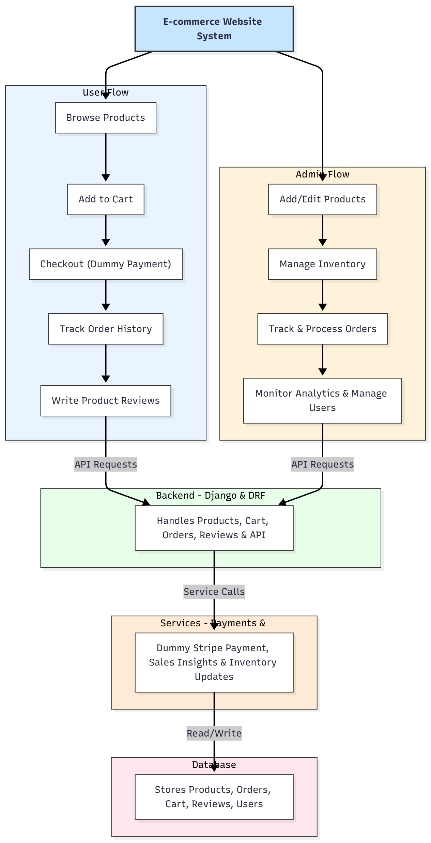

WORKING OF THE PROJECT:
The system starts with users browsing products displayed on the storefront. When users add items to the cart, Redux manages the state and ensures smooth cart updates. During checkout, the dummy payment system simulates real transaction flow using Stripe-js. The backend stores orders and handles inventory updates. Users can later track order history and submit product reviews. Administrators access a dedicated dashboard to add/edit products, monitor stock, manage orders, process deliveries, and review analytics. All interactions flow through Django REST APIs, ensuring reliability, security, and performance. Data is stored in a structured SQL database, enabling efficient reporting and insights..

SOFTWARE REQUIREMENT:
- Backend:
  - Python 3.x
  - Django
  - Django REST Framework
  - SQLite/PostgreSQL
- Frontend:
  - Node.js and npm
  - React.js
  - Axios
- Development Tools:
  - Visual Studio Code
  - Postman (for testing APIs)
  - Git/GitHub (for version control)
- Server/Deployment (Optional):
  - Gunicorn, Nginx, or Heroku/AWS for hosting

ADVANTAGES OF THE PROJECT:

• Supports complete online shopping workflow.
• Cart and checkout system with dummy payment simulation.
• Real-time inventory and order tracking.
• Product reviews to enhance customer trust.
• Admin dashboard for managing orders, users, and analytics.
• Highly scalable, suitable for small or large product catalogs.
• Secure authentication and clean API structure.
• React + Redux ensures fast and smooth UI interactions.

APPLICATIONS OF THE PROJECT:
• Product-based online stores
• Food, grocery, and essentials delivery businesses
• Electronics and gadget shops
• Fashion and accessories stores
• Service and rental-based sales

REFERENCES:

- Django REST Framework Documentation — Django Software Foundation. Django Documentation. Available: https://docs.djangoproject.com/
- Django REST Framework. DRF Documentation. Available: https://www.django-rest-framework.org/
- React. React Official Documentation. Available: https://reactjs.org/docs/getting-started.html
- Redux. Redux Documentation. Available: https://redux.js.org/introduction/getting-started
- PostgreSQL Global Development Group. PostgreSQL Documentation. Available: https://www.postgresql.org/docs/
- MySQL. MySQL Reference Manual. Available: https://dev.mysql.com/doc/
- Git. Git Documentation. Available: https://git-scm.com/doc
- Node.js. Node.js Documentation. Available: https://nodejs.org/en/docs/
- Axios. Axios Documentation. Available: https://axios-http.com/docs/intro
- Socket.io Documentation – https://socket.io/docs/

